COS209 – PROJECT DOCUMENTATION

HDICT

Thaw Myo Han

2024

Contents

SECTION A - SPECIFICATION & PROJECT MANAGEMENT 1

Project Overview 1

Company Background 1

Project Initiation 1

Scope of the System 1

Methodologies 2

Change Management Procedures 3

Software Decision 3

Requirement definition 4

Problems Definition 4

New System Functions (Informal Description) 4

Hardware Requirements and Other Constraints (Informal Description) 5

Feasibility Study 5

Scope of Work (Work Breakdown Structure) 6

Phase 1: Research and Planning 6

Phase 2: Designing Database 6

Phase 3: Website Development 7

Phase 4: Testing and Quality Assurance 7

Phase 5: Project Finalization 8

Gantt Chart 9

Budget Summary 10

SECTION B - SYSTEM REQUIREMENTS SPECIFICATIONS AND ANALYSIS 11

Use Case diagrams 11

1st Level DFD 12

2nd Level DFD 13

Process descriptions 14

Data dictionary 17

Normalization 22

First Normalization 22

Second Normalization 23

Third Normalization 23

Entity Relationship Diagram 24

SECTION C - SYSTEM DESIGN SPECIFCIATIONS 25

Database design 25

Hierarchy Chart 29

Mini-specifications for Customer 30

Mini-specifications for Administrators 31

Interface designs 32

Security features of the system 37

SECTION D - TESTING DOCUMENTATION & IMPLEMENTATION 39

TESTING 39

Test Plan 1 Functional Testing 39

Test Plan 2 Security Testing 44

System implementation 49

An implementation plan including conversion procedures 49

Section E - Critical Appraisal 51

Limitations of the System 51

Recommended Changes 51

Critical Reflection of the Project Experience 52

# SECTION A - SPECIFICATION & PROJECT MANAGEMENT

## Project Overview

### Company Background

SEEKER Sneaker is a forward-thinking footwear company committed to merging style with sustainability. Founded in 2023, our journey began with a simple vision: to sell sneakers that not only look good but also contribute positively to the environment and communities we serve. As advocates for conscious consumerism, we believe that fashion should not come at the expense of the planet.

Driven by innovation and guided by our values, SEEKER Sneaker has quickly emerged as a leader in the sustainable fashion industry. Our team of designers, engineers, and sustainability experts work tirelessly to push the boundaries of eco-friendly footwear, utilizing cutting-edge materials and manufacturing processes to minimize our environmental footprint.

### Project Initiation

The SEEKER Sneaker Website Development project aims to leverage the opportunities presented by the digital marketplace by creating an innovative and user-centric e-commerce platform dedicated to the sale of sneakers. The project marks a strategic move for SEEKER Enterprises to expand its reach, enhance customer engagement, and drive revenue growth in an increasingly competitive landscape.

### Scope of the System

The scope of the project encompasses the design, development, and launch of an intuitive, visually appealing e-commerce website tailored specifically for sneaker enthusiasts. This includes:

* Website Design: Developing a visually appealing and user-friendly website interface with intuitive navigation, responsive design, and engaging visuals to enhance the overall user experience.
* E-commerce Functionality: Implementing essential e-commerce features such as comprehensive product listings, robust search functionality, a seamless shopping cart experience, secure payment gateways, and efficient order management systems to facilitate hassle-free transactions.
* Inventory Management: Integrating inventory management systems to accurately track stock levels, manage product variations, and automate reordering processes, ensuring optimal inventory control and customer satisfaction.

By combining these elements, the project aims to deliver a comprehensive e-commerce solution that meets the needs and expectations of both SEEKER Sneaker Website users and the business stakeholders.

### Methodologies

The project will follow Agile methodologies, known for their iterative approach and adaptability to changing requirements. Agile methodologies offer several advantages, including:

* **Iterative Development:** Agile methodologies emphasize breaking the project into small, manageable increments called sprints, allowing for continuous development and improvement over time.
* **Quick Adaptation:** Agile enables teams to respond swiftly to changing requirements and market dynamics by embracing change as a natural part of the development process.
* **Collaboration:** Agile promotes collaboration among cross-functional team members, fostering a culture of communication and teamwork essential for project success.
* **Transparency:** Agile methodologies prioritize transparency, with regular meetings, progress updates, and demonstrations ensuring stakeholders are informed and involved throughout the project lifecycle.
* **Flexibility:** Agile frameworks, such as Scrum and Kanban, provide flexibility in how teams organize their work and adapt their processes to suit the unique needs of the project.
* **Continuous Improvement:** Agile encourages continuous improvement through frequent retrospectives, where teams reflect on their processes and identify areas for enhancement, driving ongoing innovation and efficiency.

### Change Management Procedures

* **Standardized Process:** The project will establish a standardized change request process to ensure consistency and clarity in documenting and assessing any alterations to project requirements or scope.
* **Documentation:** Change requests will be documented comprehensively, detailing the nature of the change, its rationale, potential impacts, and proposed solutions.
* **Thorough Review:** Each change request will undergo thorough review by the project team, including stakeholders and subject matter experts, to assess its feasibility, implications, and alignment with project objectives.
* **Approval Process:** Change requests will require formal approval by designated authorities, such as the Project Manager or Steering Committee, to ensure alignment with project goals and objectives.
* **Impact Assessment:** Change requests will be evaluated for their potential impacts on schedule, budget, and overall project objectives, with appropriate risk mitigation strategies implemented to address any identified risks.

### Software Decision

* **Modern Technologies:** The development team will utilize modern web development technologies, including HTML, CSS, JavaScript, and PHP, to build the e-commerce website. These technologies are widely recognized for their versatility, performance, and compatibility with a diverse range of platforms and devices.
* **Alignment with Objectives:** Approval from the Supervisor will be sought to confirm that the chosen technologies align with project objectives and requirements, ensuring that the technical stack selected is capable of delivering the desired functionalities and performance metrics.
* **Scalability and Maintainability:** The chosen technologies are known for their scalability and maintainability, allowing for future enhancements and updates to be implemented seamlessly as the project evolves and customer needs change.
* **Community Support:** HTML, CSS, JavaScript, and PHP benefit from extensive community support, with a wealth of resources, libraries, and frameworks available to streamline development efforts and address any technical challenges encountered during the project lifecycle.

By implementing robust change management procedures and selecting appropriate software technologies, the project aims to minimize disruptions, maximize efficiency, and deliver a high-quality e-commerce solution that meets stakeholder expectations and fulfills market demands effectively.

## Requirement definition

### Problems Definition

The current absence of an online platform for sneaker sales restricts SEEKER Enterprises' market reach and revenue potential. Key issues include:

* Limited accessibility: Customers are confined to purchasing sneakers from physical retail locations, limiting convenience and accessibility.
* Geographic constraints: SEEKER's brick-and-mortar stores restrict sales to local customers, missing out on opportunities to reach a broader audience.
* Inefficient inventory management: Manual inventory tracking processes lead to inaccuracies, stockouts, and missed sales opportunities.

### New System Functions (Informal Description)

The SEEKER Sneaker Website will offer a range of features to enhance the shopping experience for customers:

* User-friendly interface: Intuitive navigation and visually appealing design to facilitate seamless browsing and product discovery.
* Comprehensive product listings: Extensive catalog of sneakers from leading brands, with detailed descriptions, images, and sizing information.
* Secure shopping cart: Easy-to-use shopping cart functionality allowing customers to add, remove, and modify items before checkout.
* Multiple payment options: Integration of secure payment gateways to accept various payment methods, including credit/debit cards, PayPal, and digital wallets.
* Order tracking: Real-time order tracking functionality enabling customers to monitor the status of their purchases from placement to delivery.
* Personalized user accounts: Customer accounts for managing preferences, tracking order history, and receiving personalized recommendations.
* Responsive design: Mobile-friendly layout ensuring optimal viewing and functionality across devices, including smartphones, tablets, and desktop computers.

### Hardware Requirements and Other Constraints (Informal Description)

The SEEKER Sneaker Website development will be subject to the following hardware requirements and constraints:

* Hosting server: Reliable web hosting service capable of handling high traffic volumes and ensuring 24/7 uptime for uninterrupted access to the website.
* Internet connectivity: Stable internet connection to support seamless data transfer and online transactions.
* Compatibility: Compatibility with a wide range of devices and browsers to accommodate diverse user preferences and ensure a consistent user experience.
* Security: Implementation of robust security measures to safeguard customer data, protect against cyber threats, and ensure secure online transactions.
* Scalability: Scalable architecture and infrastructure to accommodate future growth in website traffic and user engagement without compromising performance or reliability.

### Feasibility Study

A feasibility study conducted prior to the commencement of the project indicates the viability and potential benefits of the SEEKER Sneaker Website development:

* Technical feasibility: The availability of modern web development technologies and tools makes it feasible to develop an e-commerce platform meeting SEEKER's requirements.
* Economic feasibility: The projected return on investment (ROI) from increased online sales revenue, expanded market reach, and improved operational efficiency outweighs the costs associated with website development and maintenance.
* Operational feasibility: SEEKER's existing infrastructure, resources, and expertise position the company favorably to undertake and manage the development and maintenance of the e-commerce website effectively.

The requirements defined above serve as the foundation for the development of the SEEKER Sneaker Website, ensuring alignment with both client expectations and developer capabilities.

## Scope of Work (Work Breakdown Structure)

### Phase 1: Research and Planning

**Task 1: Conduct Market Research**

* Gather data on current trends, consumer preferences, and competitor analysis in the sneaker industry.
* Analyze market dynamics to identify opportunities and challenges for the website development project.

**Task 2: Define Project Objectives and Scope**

* Establish clear project objectives, including goals for website functionality, design, and user experience.
* Define the scope of work, outlining the features, functionalities, and deliverables expected from the website.

**Task 3: Allocate Resources and Establish Timelines**

* Identify and allocate human and financial resources required for the project, including project team members and budget allocation.
* Develop a detailed project timeline, including milestones and deadlines for each phase of the project.

### Phase 2: Designing Database

**Task 1: Database Schema Design**

* Design the structure and relationships of the database to efficiently store and manage data related to products, customers, orders, etc.
* Define tables, fields, and constraints to ensure data integrity and optimize query performance.

**Task 2: Database Implementation**

* Implement the database schema using appropriate database management systems (DBMS) such as MySQL, PostgreSQL, or MongoDB.
* Populate the database with sample data for testing and validation purposes.

### Phase 3: Website Development

**Task 1: Frontend Development**

* Design and develop the user interface (UI) of the website using HTML, CSS, and JavaScript.
* Create visually appealing layouts and intuitive navigation to enhance the user experience.

**Task 2: Backend Development**

* Develop server-side functionalities and business logic to support user interactions and data processing.
* Implement features such as user authentication, product management, shopping cart functionality, and order processing.

**Task 3: Integration and Testing**

* Integrate frontend and backend components to create a seamless user experience.
* Conduct thorough testing of the website to identify and fix any bugs or issues before deployment.

### Phase 4: Testing and Quality Assurance

**Task 1: Functional Testing**

* Verify that all website features and functionalities meet the specified requirements and perform as expected.
* Identify and rectify any functional defects or inconsistencies in the system behavior.

**Task 2: Usability Testing and Bug Fixing**

* Evaluate the website's usability and user experience through real-world testing scenarios and user feedback.
* Address any usability issues or bugs discovered during testing through iterative bug fixing and enhancements.

**Task 3: Compatibility Testing**

* Test the website's compatibility across various devices, browsers, and screen sizes to ensure consistent performance and appearance.
* Address any compatibility issues to ensure a seamless user experience for all users.

### Phase 5: Project Finalization

**Task 1: Deployment**

* Prepare the website for deployment to a production environment.
* Configure web servers, domain settings, and SSL certificates for secure access.

**Task 2: Launch and Post-launch Support**

* Deploy the website to the live server and monitor its performance and stability.
* Provide ongoing support and maintenance to address any issues or updates post-launch and ensure customer satisfaction.

## Gantt Chart

Figure 1 Gantt Chart 1

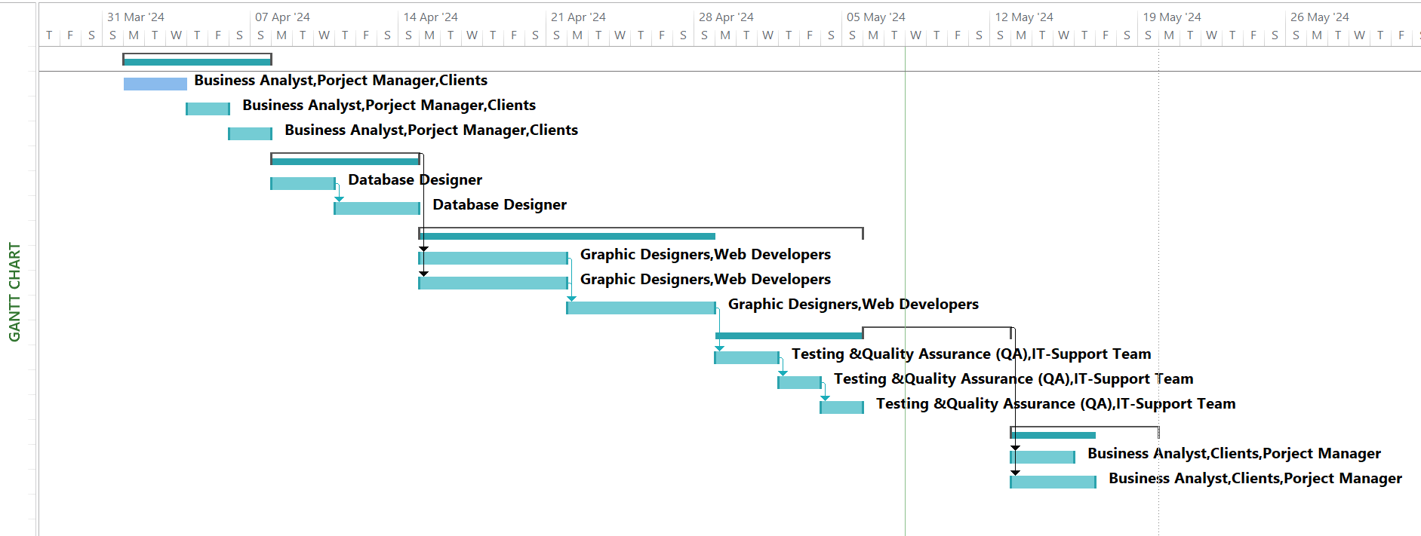

Figure 2 Gantt Chart 2

## Budget Summary

|  |  |  |  |  |  |  |
| --- | --- | --- | --- | --- | --- | --- |
| Phases | Stages | Start Dates | End Dates | Duration | | Estimated Costs |
| Phase 1 | Research and Planning | 1.4.2024 | 7.4.2024 | 1 week | |  |
|  | - Project Manager-1person |  |  |  | | $2000 |
|  | - Business Analyst-1person |  |  |  | | $1500 |
|  | - Software/Hardware Tools |  |  |  | | $500 |
| Phase 2 | Designing Database | 8.4.2024 | 14.4.2024 | 1 week | |  |
|  | - Database Designer-1person |  |  |  | | $2000 |
|  | - Software/Hardware Tools |  |  |  | | $500 |
| Phase 3 | Website Development | 15.4.2024 | 5.5.2024 | 3 weeks | |  |
|  | - Web Developer-2people |  |  |  | | $10000 |
|  | - Graphic Designer-2people |  |  |  | | $4000 |
|  | - Software/Hardware Tools |  |  |  | | $1000 |
| Phase 4 | Testing & Quality Assurance | 6.5.2024 | 12.5.2024 | 1 week | |  |
|  | - QA Tester-2person |  |  |  | | $6000 |
|  | - IT-Support Team-2person |  |  |  | | $4000 |
|  | - Software/Hardware Tools |  |  |  | | $500 |
| Phase 5 | Project Finalization | 13.5.2024 | 19.5.2024 | 1 week | |  |
|  | - Project Manager-1person  -Stakeholders-10people  -Clients |  |  |  | $1000  $700 per person | |
| Total Estimated Costs | | | | | | $40000 |

# SECTION B - SYSTEM REQUIREMENTS SPECIFICATIONS AND ANALYSIS

## Use Case diagrams

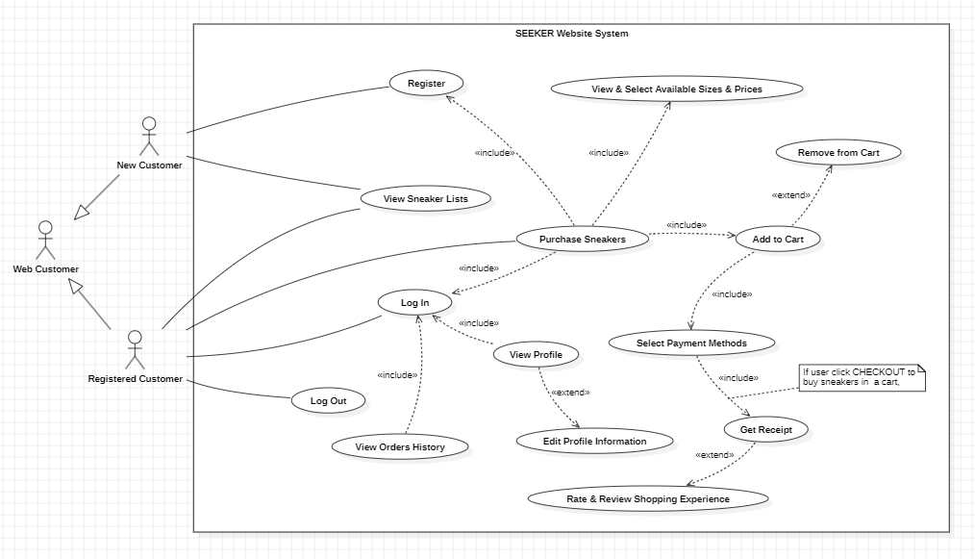

Figure 3 Use Case Diagram for Web Customer

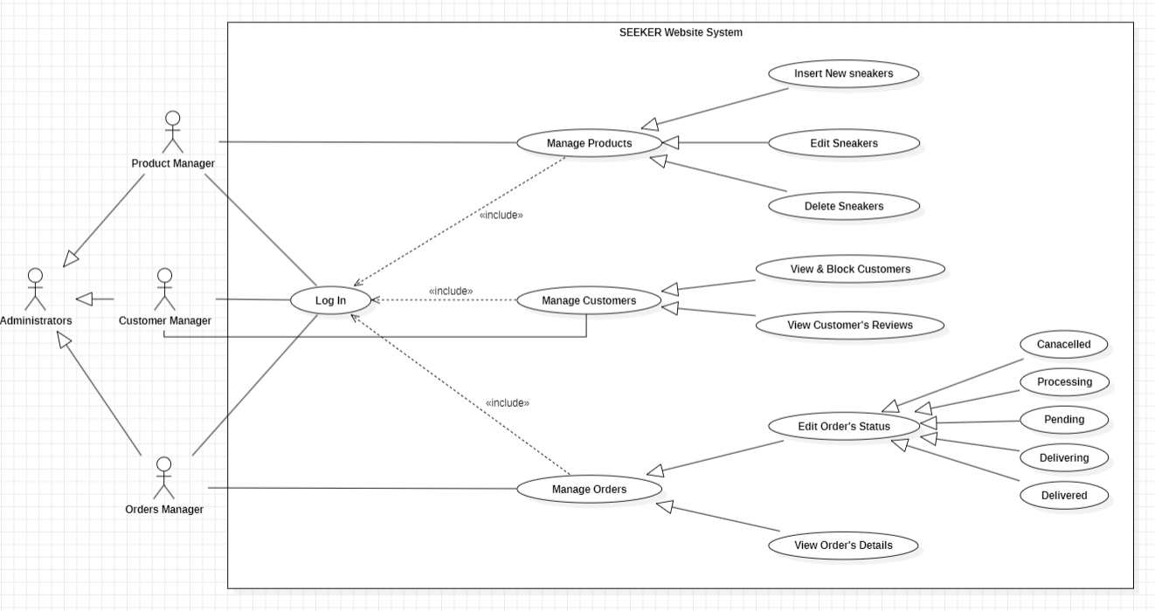

Figure 4 Use Case Diagram for Administrators

## 1st Level DFD

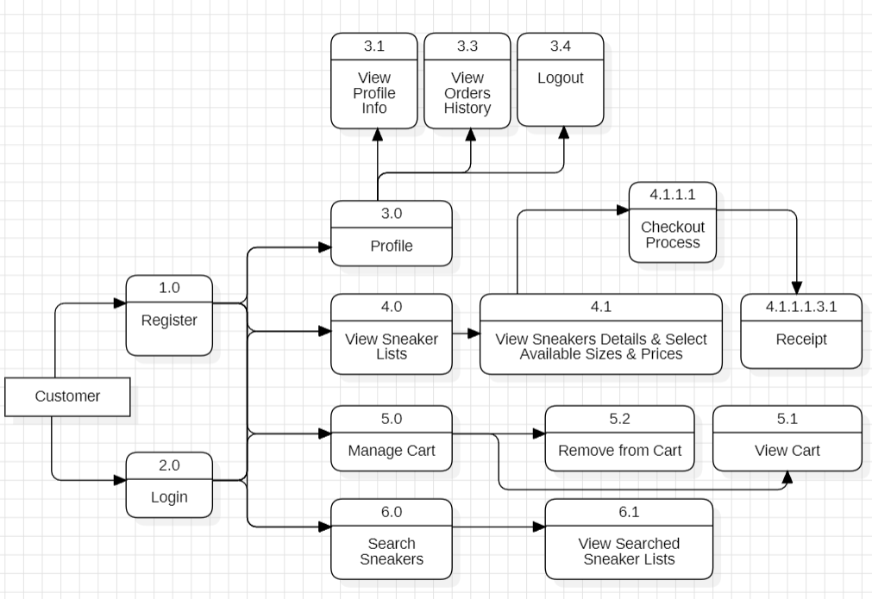

Figure 5 1st Level DFD for Customer

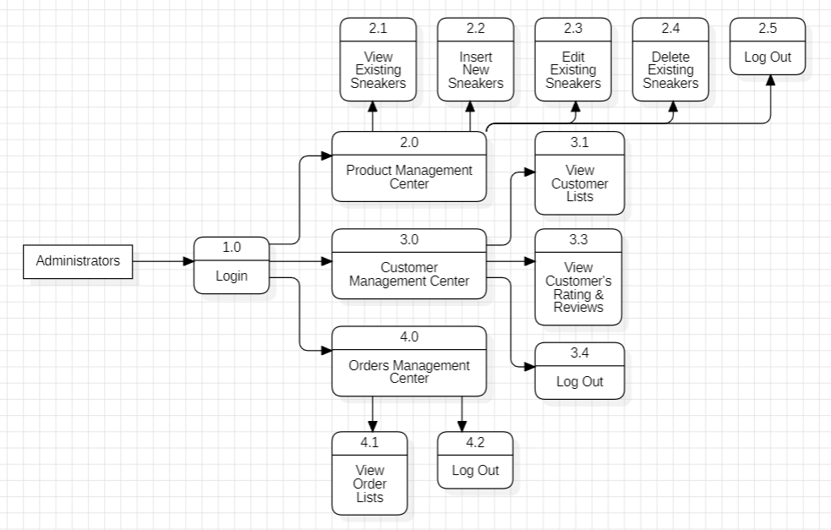

Figure 6 1st Level DFD for Administrators

## 2nd Level DFD

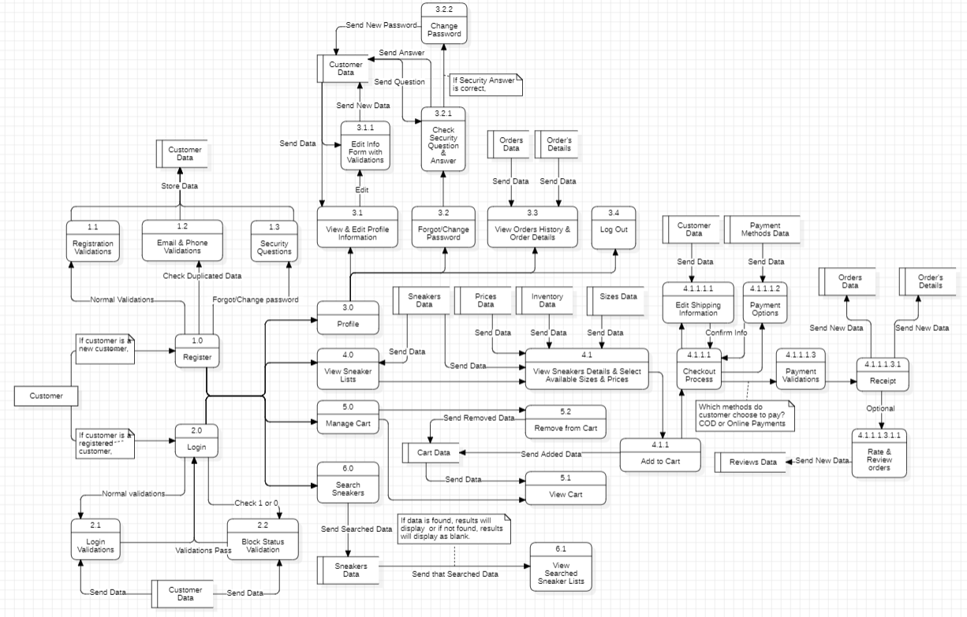

Figure 7 2nd Level DFD for Customer

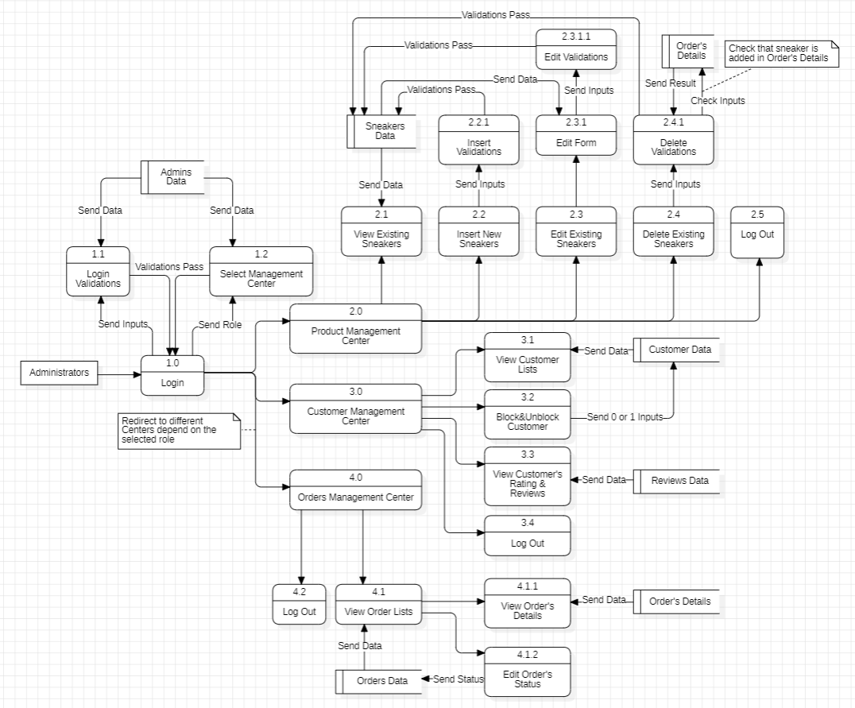

Figure 8 2nd Level DFD for Administrators

## Process descriptions

|  |  |
| --- | --- |
| Process Name | Descriptions |
| **Phase 1: Research and Planning** | |
| Task 1: Conduct Market Research | * Gather data on current trends, consumer preferences, and competitor analysis in the sneaker industry. * Analyze market dynamics to identify opportunities and challenges for the website development project. |
| Task 2: Define Project Objectives and Scope | * Establish clear project objectives, including goals for website functionality, design, and user experience. * Define the scope of work, outlining the features, functionalities, and deliverables expected from the website. |
| Task 3: Allocate Resources and Establish Timelines | * Identify and allocate human and financial resources required for the project, including project team members and budget allocation. * Develop a detailed project timeline, including milestones and deadlines for each phase of the project. |
| **Phase 2: Designing Database** | |
| Task 1: Database Schema Design | * Design the structure and relationships of the database to efficiently store and manage data related to products, customers, orders, etc. * Define tables, fields, and constraints to ensure data integrity and optimize query performance. |
| Task 2: Database Implementation | * Implement the database schema using appropriate database management systems (DBMS) such as MySQL or MongoDB. * Populate the database with sample data for testing and validation purposes. |
| **Phase 3: Website Development** | |
| Task 1: Frontend Development | * Design and develop the user interface (UI) of the website using HTML, CSS, and JavaScript. * Create visually appealing layouts and intuitive navigation to enhance the user experience. |
| Task 2: Backend Development | * Develop server-side functionalities and business logic to support user interactions and data processing. * Implement features such as user authentication, product management, shopping cart functionality, and order processing. |
| Task 3: Integration and Testing | * Integrate frontend and backend components to create a seamless user experience. * Conduct thorough testing of the website to identify and fix any bugs or issues before deployment. |
| **Phase 4: Testing and Quality Assurance** | |
| Task 1: Functional Testing | * Verify that all website features and functionalities meet the specified requirements and perform as expected. * Identify and rectify any functional defects or inconsistencies in the system behavior. |
| Task 2: Usability Testing and Bug Fixing | * Evaluate the website's usability and user experience through real-world testing scenarios and user feedback. * Address any usability issues or bugs discovered during testing through iterative bug fixing and enhancements. |
| Task 3: Compatibility Testing | * Test the website's compatibility across various devices, browsers, and screen sizes to ensure consistent performance and appearance. * Address any compatibility issues to ensure a seamless user experience for all users. |
| **Phase 5: Project Finalization** | |
| Task 1: Deployment | * Prepare the website for deployment to a production environment. * Configure web servers, domain settings, and SSL certificates for secure access. |
| Task 2: Launch and Post-launch Support | * Deploy the website to the live server and monitor its performance and stability. * Provide ongoing support and maintenance to address any issues or updates post-launch and ensure customer satisfaction. |

## Data dictionary

|  |  |  |  |  |  |
| --- | --- | --- | --- | --- | --- |
| Data Name/  Field Name | Table | Data Type | Max Field Size | Constraint | Description |
| customerid | customer | int | 11 | Primary Key  Auto Increment | Unique identifier for each customer |
| firstname | customer | varchar | 100 | No Null | First name of the customer |
| lastname | customer | varchar | 100 | No Null | Last name of the customer |
| email | customer | varchar | 100 | No Null | Email address of the customer |
| address | customer | text |  | No Null | Postal address of the customer |
| city | customer | varchar | 100 | No Null | City of residence for the customer |
| country | customer | varchar | 100 | No Null | Country of residence for the customer |
| phone | customer | varchar | 11 | No Null | Phone number of the customer |
| password | customer | varchar | 20 | No Null | Password for account |
| security_question | customer | varchar | 200 | No Null | Security question chosen by the customer for forgot or change password |
| security_answer | customer | varchar | 200 | No Null | Answer to the security question provided by the customer |
| Block | customer | int | 11 | No Null | Block status of the customer account (e.g., 1 or 0) |

|  |  |  |  |  |  |
| --- | --- | --- | --- | --- | --- |
| Data Name/  Field Name | Table | Data Type | Max Field Size | Constraint | Description |
| sneakerid | sneakers | int | 11 | Primary Key  Auto Increment | Unique identifier for each sneaker |
| name | sneakers | varchar | 200 | No Null | Name of the sneaker |
| brand | sneakers | varchar | 200 | No Null | Brand of the sneaker |
| nickname | sneakers | varchar | 200 | No Null | Nickname of the sneaker |
| description | sneakers | text |  | No Null | Description of the sneaker |
| colorway | sneakers | varchar | 100 | No Null | Colorway of the sneaker |
| gender | sneakers | varchar | 100 | No Null | Gender of the sneaker |
| releasedate | sneakers | date |  | No Null | Released Date of the sneaker |
| Image | sneakers | longblob |  | No Null | High Quality Image of the sneaker |

|  |  |  |  |  |  |
| --- | --- | --- | --- | --- | --- |
| Data Name/  Field Name | Table | Data Type | Max Field Size | Constraint | Description |
| sizeid | sizes | int | 11 | Primary Key  Auto Increment | Unique identifier for each size |
| sizename | sizes | Int | 11 | No Null | Name of the size |

|  |  |  |  |  |  |
| --- | --- | --- | --- | --- | --- |
| Data Name/  Field Name | Table | Data Type | Max Field Size | Constraint | Description |
| Inventory_id | inventory | int | 11 | Primary Key  Auto Increment | Unique identifier for each inventory |
| sneakerid | inventory | int | 11 | Foreign Key from sneakers | Unique identifier of the sneaker |
| sizeid | inventory | int | 11 | Foreign Key from sizes | Unique identifier of the size |
| quantity | inventory | int | 11 | No Null | Quantity of that sneakerid of that sizeid |

|  |  |  |  |  |  |
| --- | --- | --- | --- | --- | --- |
| Data Name/  Field Name | Table | Data Type | Max Field Size | Constraint | Description |
| price_id | prices | int | 11 | Primary Key  Auto Increment | Unique identifier for each price |
| sneakerid | prices | int | 11 | Foreign Key from sneakers | Unique identifier of the sneaker |
| sizeid | prices | int | 11 | Foreign Key from sizes | Unique identifier of the size |
| price | prices | float | 11 | No Null | Price of that sneakerid in that sizeid |

|  |  |  |  |  |  |
| --- | --- | --- | --- | --- | --- |
| Data Name/  Field Name | Table | Data Type | Max Field Size | Constraint | Description |
| cartid | cart | int | 11 | Primary Key  Auto Increment | Unique identifier for each cart |
| customerid | cart | int | 11 | Foreign Key from customer | Unique identifier of the customer |
| sneakerid | cart | int | 11 | Foreign Key from sneakers | Unique identifier of the sneaker |
| sizeid | cart | int | 11 | Foreign Key from sizes | Unique identifier of the size |
| date | cart | date |  | No Null | Date of the added item into cart |

|  |  |  |  |  |  |
| --- | --- | --- | --- | --- | --- |
| Data Name/  Field Name | Table | Data Type | Max Field Size | Constraint | Description |
| methodid | paymentmethods | int | 11 | Primary Key  Auto Increment | Unique identifier for each payment method |
| paymentmethod | paymentmethods | varchar | 20 | No Null | Name of paymentmethods |
| image | paymentmethods | blob |  | Yes Null | Image of QR Code |
| accountname | paymentmethods | varchar | 50 | Yes Null | Name of account |
| company | paymentmethods | blob |  | Yes Null | Image of Company |

|  |  |  |  |  |  |
| --- | --- | --- | --- | --- | --- |
| Data Name/  Field Name | Table | Data Type | Max Field Size | Constraint | Description |
| orderid | orders | int | 11 | Primary Key  Auto Increment | Unique identifier for each order |
| customerid | orders | int | 11 | Foreign Key from customer | Unique identifier of the customer |
| orderdate | orders | date |  |  | Date of the order |
| paymethod | orders | varchar | 50 | Foreign Key from paymentmethods | Unique identifier of the payment methods |
| transactionno | orders | varchar | 200 | No Null | Transaction Number of payment methods |
| totalamount | orders | Float |  | No Null | Total Amount of the order |
| status | orders | varchar | 50 | No Null | Status of order |

|  |  |  |  |  |  |
| --- | --- | --- | --- | --- | --- |
| Data Name/  Field Name | Table | Data Type | Max Field Size | Constraint | Description |
| orderdetailid | orderdetail | int | 11 | Primary Key  Auto Increment | Unique identifier for each orderdetail |
| orderid | orderdetail | int | 11 | Foreign Key from orders | Unique identifier of the order |
| sneakerid | orderdetail | int | 11 | Foreign Key from sneakers | Unique identifier of the sneaker |
| sizeid | orderdetail | int | 11 | Foreign Key from sizes | Unique identifier of the size |
| unitprice | orderdetail | int | 11 | Foreign Key from prices | Unique identifier of the price |

|  |  |  |  |  |  |
| --- | --- | --- | --- | --- | --- |
| Data Name/  Field Name | Table | Data Type | Max Field Size | Constraint | Description |
| reviewid | review | int | 11 | Primary Key  Auto Increment | Unique identifier for each review |
| customerid | review | int | 11 | Foreign Key from customer | Unique identifier of the customer |
| orderid | review | int | 11 | Foreign Key from orders | Unique identifier of the order |
| rating | review | int | 11 | No Null | Rating 1 to 5 |
| comment | review | text |  | No Null | Comment of customer |
| date | review | date |  | No Null | Date of review |

|  |  |  |  |  |  |
| --- | --- | --- | --- | --- | --- |
| Data Name/  Field Name | Table | Data Type | Max Field Size | Constraint | Description |
| adminid | admin | int | 11 | Primary Key  Auto Increment | Unique identifier for each administrator |
| username | admin | varchar | 100 | No Null | Username of Admin |
| role | admin | varchar | 100 | No Null | Role of Admin |
| password | admin | varchar | 100 | No Null | Password of Admin |

## Normalization

### First Normalization

**Admin Table**

|  |  |  |  |
| --- | --- | --- | --- |
| adminid | username | role | password |
| 1 | pmc001 | Product Management Center | PMC001 |

**Customer Table**

|  |  |  |  |  |  |
| --- | --- | --- | --- | --- | --- |
| customerid | firstname | lastname | email | address | city |
| 1 | Thaw Myo | Han | [thawmyohan@gmail.com](mailto:thawmyohan@gmail.com) | No(40), MarLarMyaing (8) Street, Upper Block | Yangon |
| country | phone | password | security question | security answer | block |
| Myanmar | 09253034566 | Thawmyohan002@ | What was your childhood nickname? | Phoe Thar | 0 |

**Sneakers Table**

|  |  |  |  |  |  |  |  |  |
| --- | --- | --- | --- | --- | --- | --- | --- | --- |
| sneakerid | name | brand | nickname | description | colorway | gender | releasedate | image |
| 1 | AIR JORDAN 4 RETRO | JORDAN | Thunder | The Air Jordan 4 Retro… | YELLOW | Mens | 2024-05-01 | [[BLOB - 178.3 KiB]](http://localhost/phpmyadmin/index.php?route=/table/get-field&db=seekerdb&table=sneakers&where_clause_sign=067ad19395adbc8c7e08271156dcb0fcfc1e40c5a059c3583bd22ffa395441fa&where_clause=%60sneakers%60.%60sneakerid%60+%3D+1&transform_key=image&sql_query=SELECT+%2A+FROM+%60sneakers%60) |

### Second Normalization

**Inventory Table**

|  |  |  |  |
| --- | --- | --- | --- |
| inventory_id | sneakerid | sizeid | quantity |
| 1 | 1 | 1 | 5 |

**Prices Table**

|  |  |  |  |
| --- | --- | --- | --- |
| price_id | sneakerid | sizeid | price |
| 1 | 1 | 1 | 600 |

**Cart Table**

|  |  |  |  |  |
| --- | --- | --- | --- | --- |
| cartid | customerid | sneakerid | Sizeid | date |
| 1 | 1 | 1 | 1 | 2024-05-02 |

### Third Normalization

**Order Detail Table**

|  |  |  |  |  |
| --- | --- | --- | --- | --- |
| orderdetailid | orderid | sneakerid | sizeid | unitprice |
| 1 | 1 | 1 | 1 | 600 |

## Entity Relationship Diagram

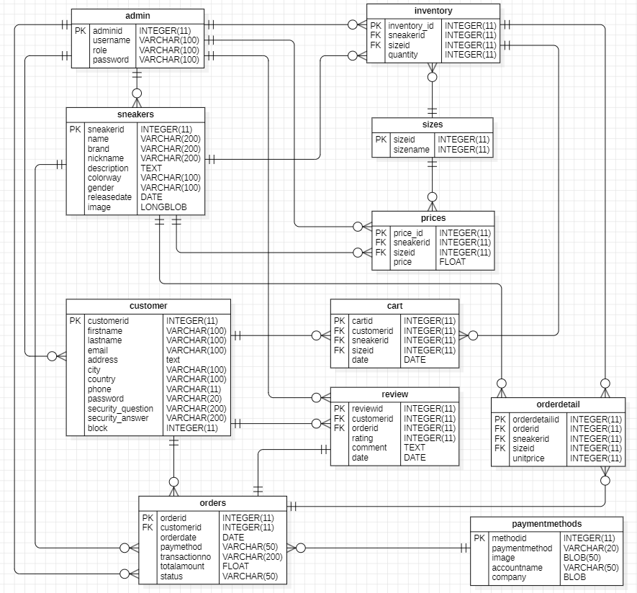

Figure 9 Entity Relationship Diagram

# SECTION C - SYSTEM DESIGN SPECIFCIATIONS

## Database design

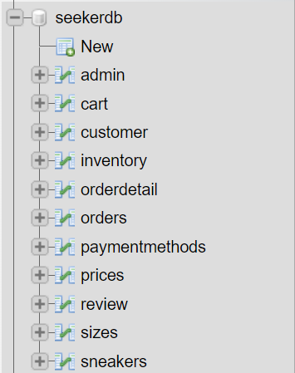

Figure 10 Database with tables

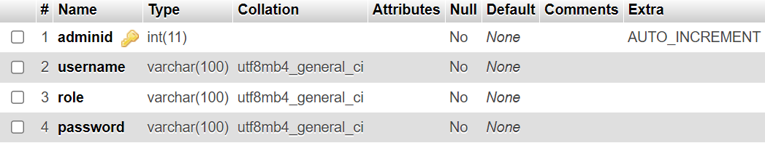

Figure 11 Data Base Design of Admin Table

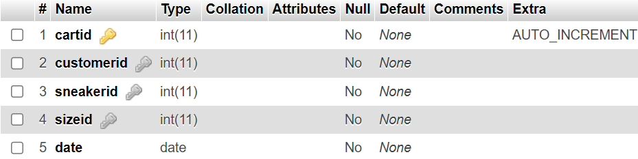

Figure 12 Data Base Design of Cart Table

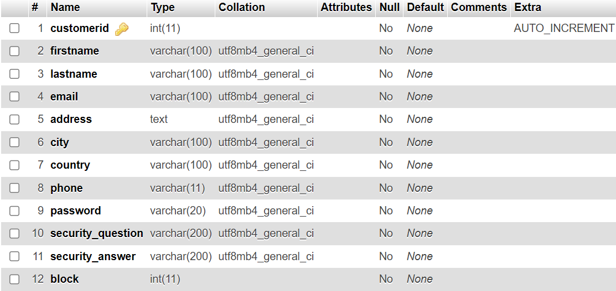

Figure 13 Data Base Design of Customer Table

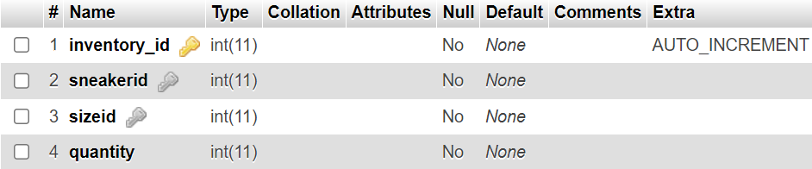

Figure 14 Data Base Design of Inventory Table

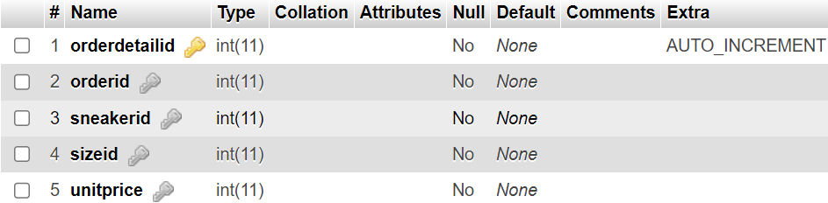

Figure 15 Data Base Design of Order Detail Table

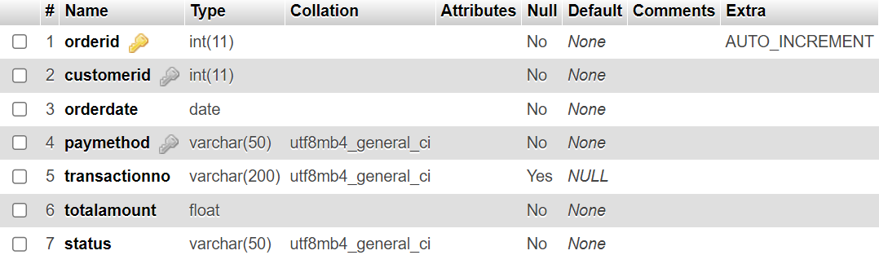

Figure 16 Data Base Design of Orders Table

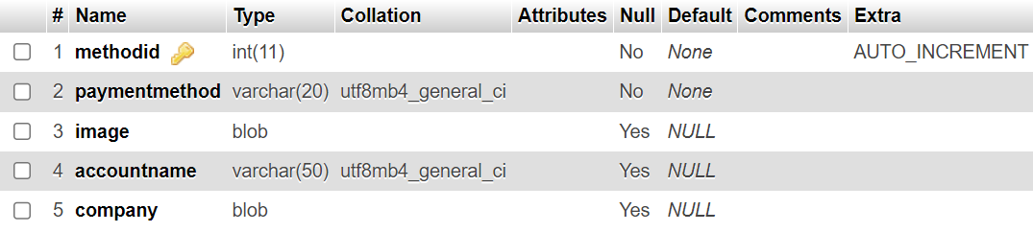

Figure 17 Data Base Design of Payment Methods Table

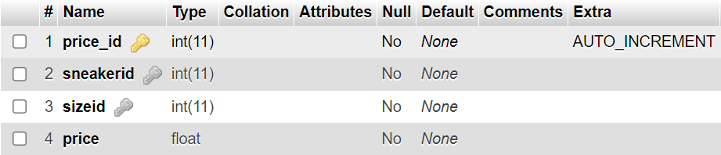

Figure 18 Data Base Design of Prices Table

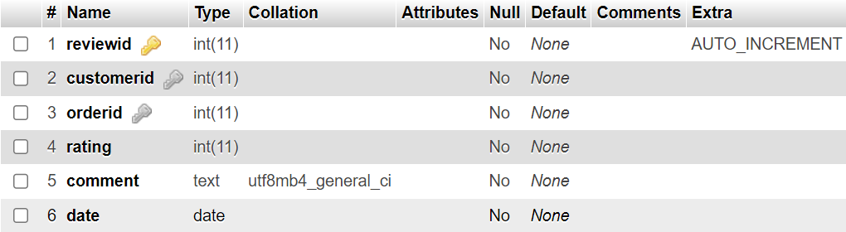

Figure 19 Data Base Design of Review Table

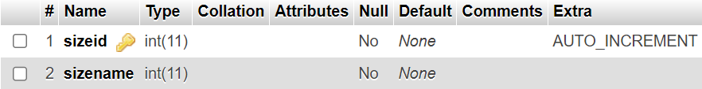

Figure 20 Data Base Design of Sizes Table

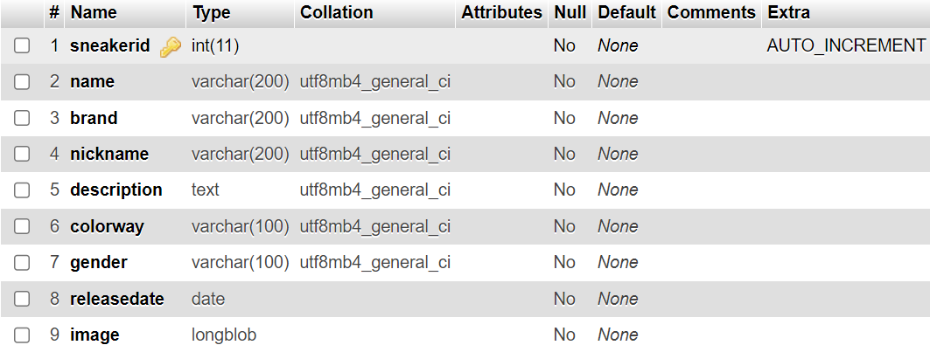

Figure 21 Data Base Design of Sneakers Table

## Hierarchy Chart

Figure 22 Hierarchy Chart of Customer

Figure 23 Hierarchy Chart of Administrators

## Mini-specifications for Customer

**Pages (Sneaker Lists):**

1. **New Releases:** Displays the latest sneaker releases.
2. **JORDAN:** Features Jordan brand sneakers.
3. **NIKE:** Showcases Nike brand sneakers.
4. **YEEZY:** Presents Yeezy brand sneakers.
5. **NEW BALANCE:** Highlights New Balance brand sneakers.
6. **ADIDAS:** Exhibits Adidas brand sneakers.
7. **WOMENS:** Dedicated section for women's sneakers.
8. **KIDS:** Dedicated section for kids' sneakers.

**Icons:**

1. **SEARCH Icon:** Allows users to search for specific products.
2. **PROFILE Icon:** Enables users to access and manage their accounts.
3. **CART Icon:** Provides access to the user's shopping cart for managing purchases.

**Functionality:**

1. **Product Listing:** Each page displays a grid of sneakers belonging to the respective category, with key product information such as name, price, and an image thumbnail.
2. **Search Functionality:** The SEARCH icon triggers a search bar where users can enter keywords to find specific products.
3. **User Accounts:** The PROFILE icon allows users to create accounts, log in, and manage their personal information, edit password and order history.
4. **Shopping Cart:** The CART icon opens a panel displaying the items added to the user's shopping cart, allowing for easy management and checkout.
5. **Responsive Design:** The website is optimized for various devices, ensuring a seamless browsing experience across desktop, tablet, and mobile platforms.

## Mini-specifications for Administrators

**Log In with Roles:**

1. **Product Management Center:**
   * **Insert Sneakers:** Admins with this role can add new sneakers to the inventory.
   * **Update Sneakers:** Admins with this role can edit existing sneaker details.
   * **Delete Sneakers:** Admins with this role can remove sneakers from the inventory.
2. **Customer Management Center:**
   * **Customer Lists:** Admins with this role can view a list of customers and their details.
     + **Edit Block Status:** Admins can toggle the block status of customers to restrict or allow their access to the website.
   * **Customer's Reviews:** Admins can access and manage customer reviews.
3. **Orders Management Center:**
   * **Order Lists:** Admins with this role can view a list of orders placed by customers.
     + **Edit Order's Status:** Admins can update the status of orders, such as processing, shipped, delivered, etc.
     + **Order's Details:** Admins can access detailed information about each order, including items purchased, payment details, and shipping information.

## Interface designs

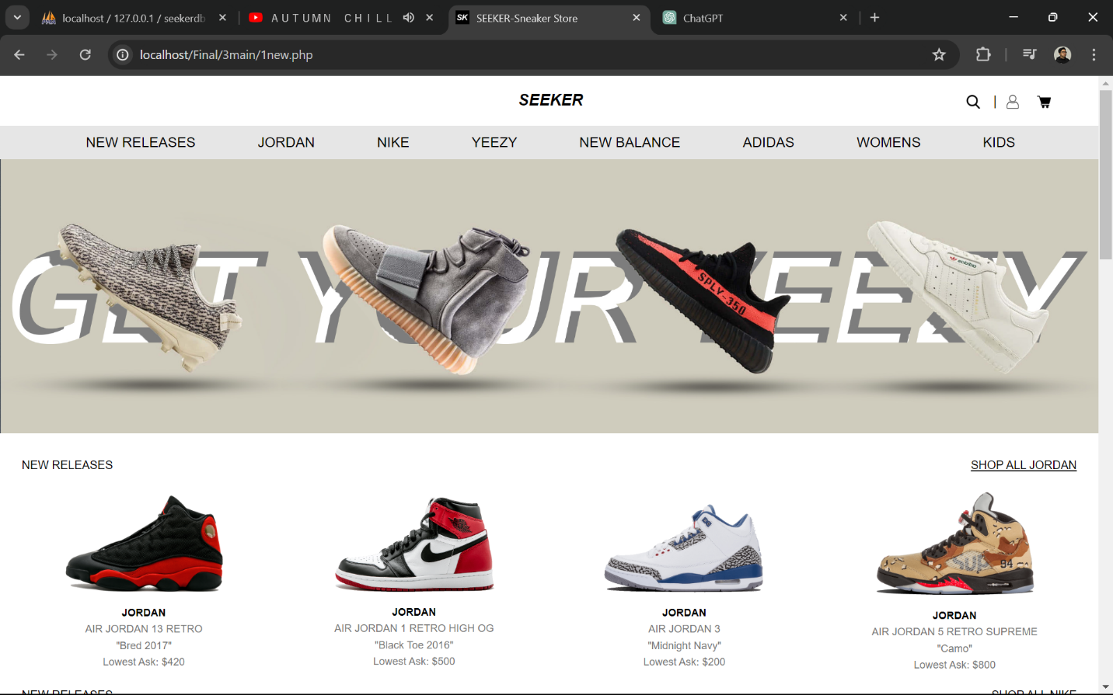

Figure 24 Home Page

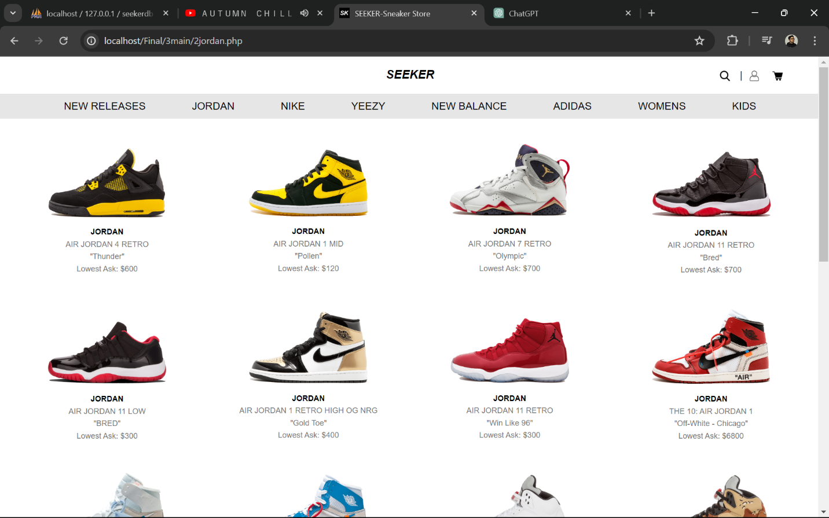

Figure 25 JORDAN Lists

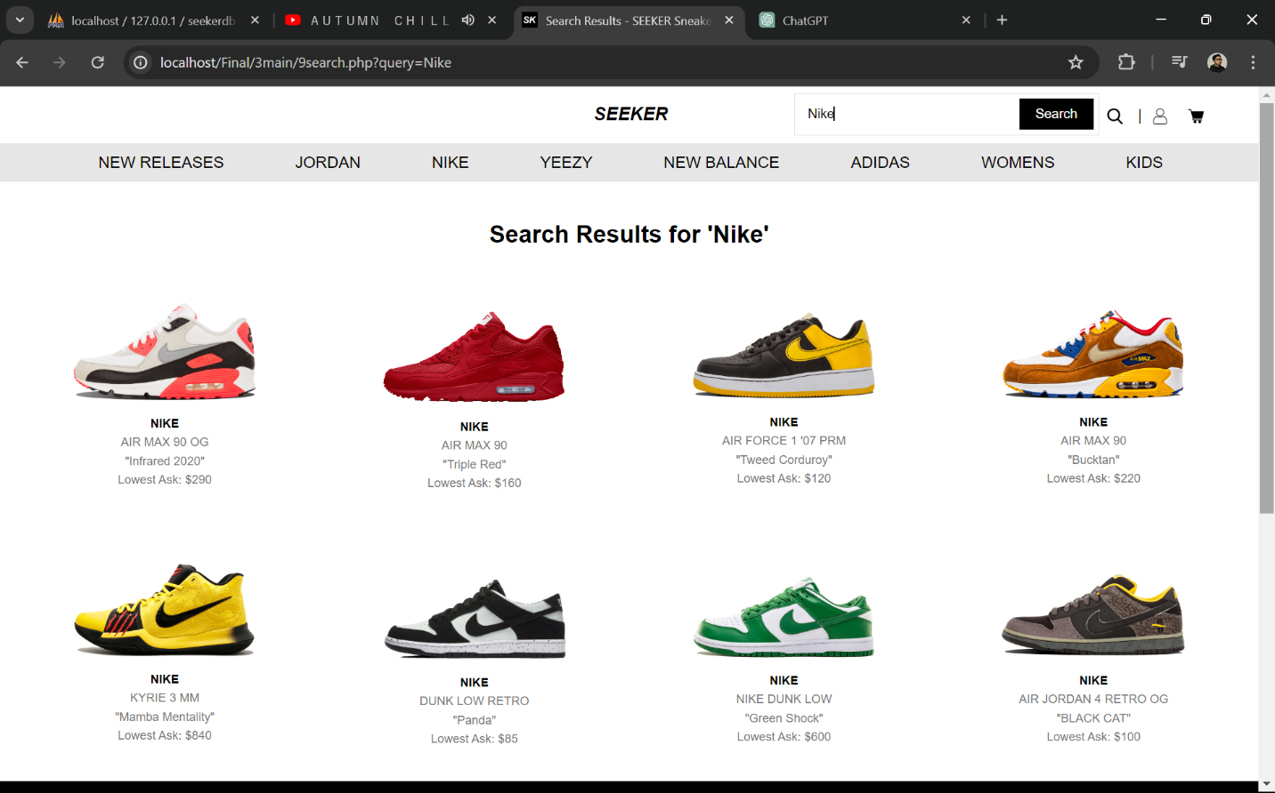

Figure 26 Searched Sneakers Lists

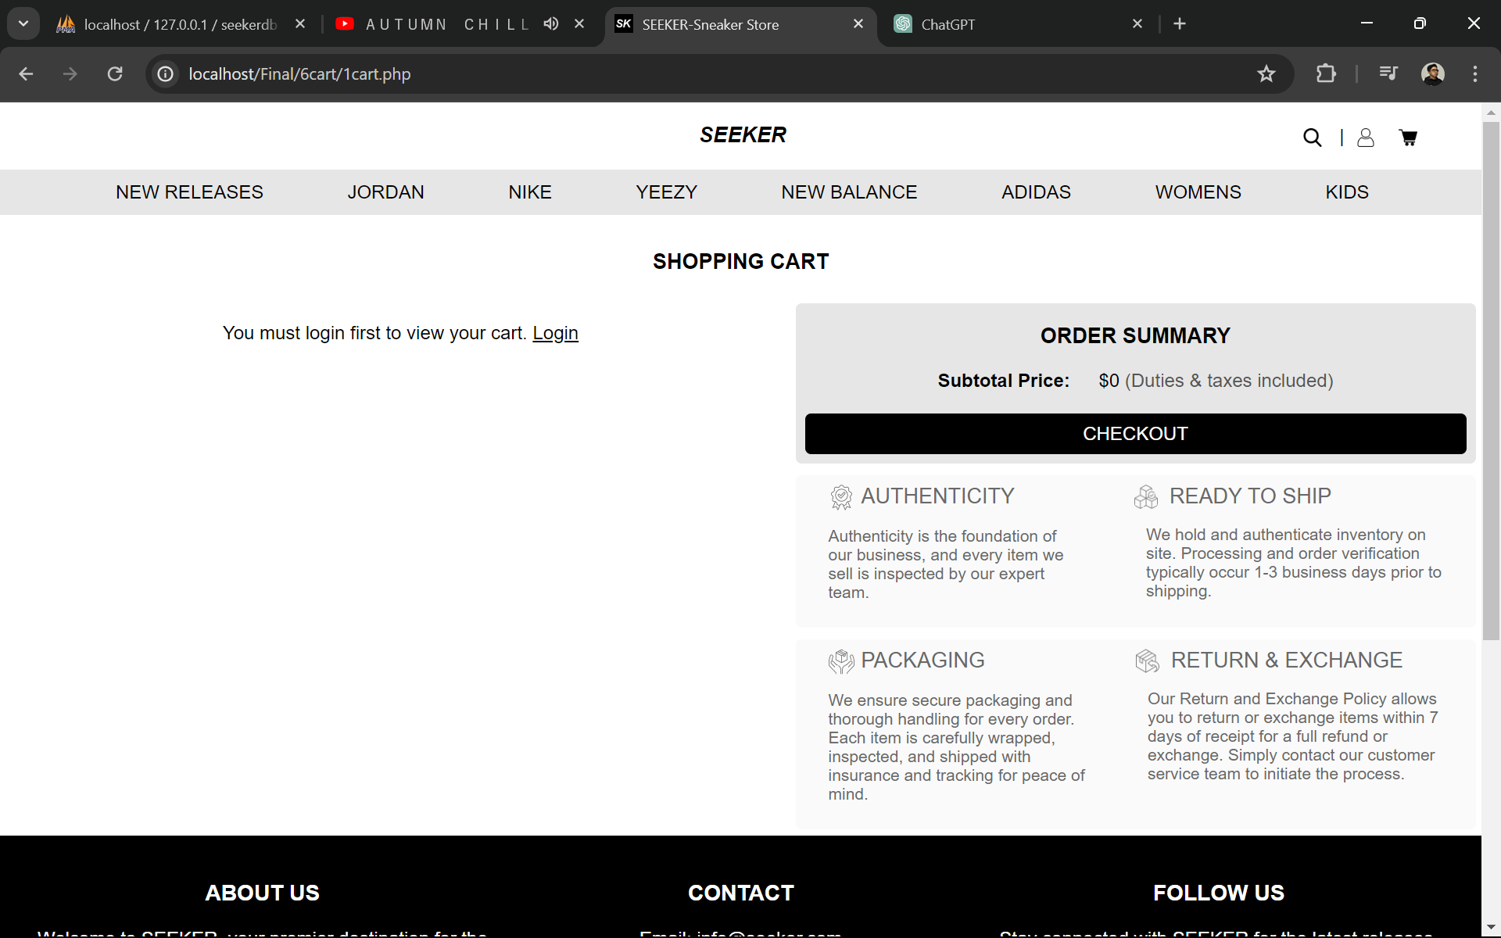

Figure 27 Cart

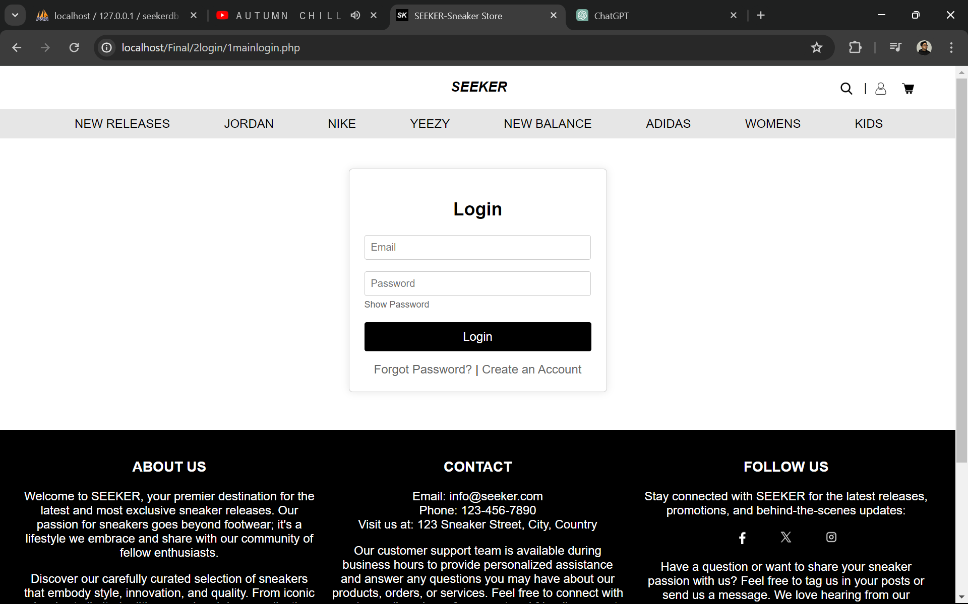

Figure 28 Login Form

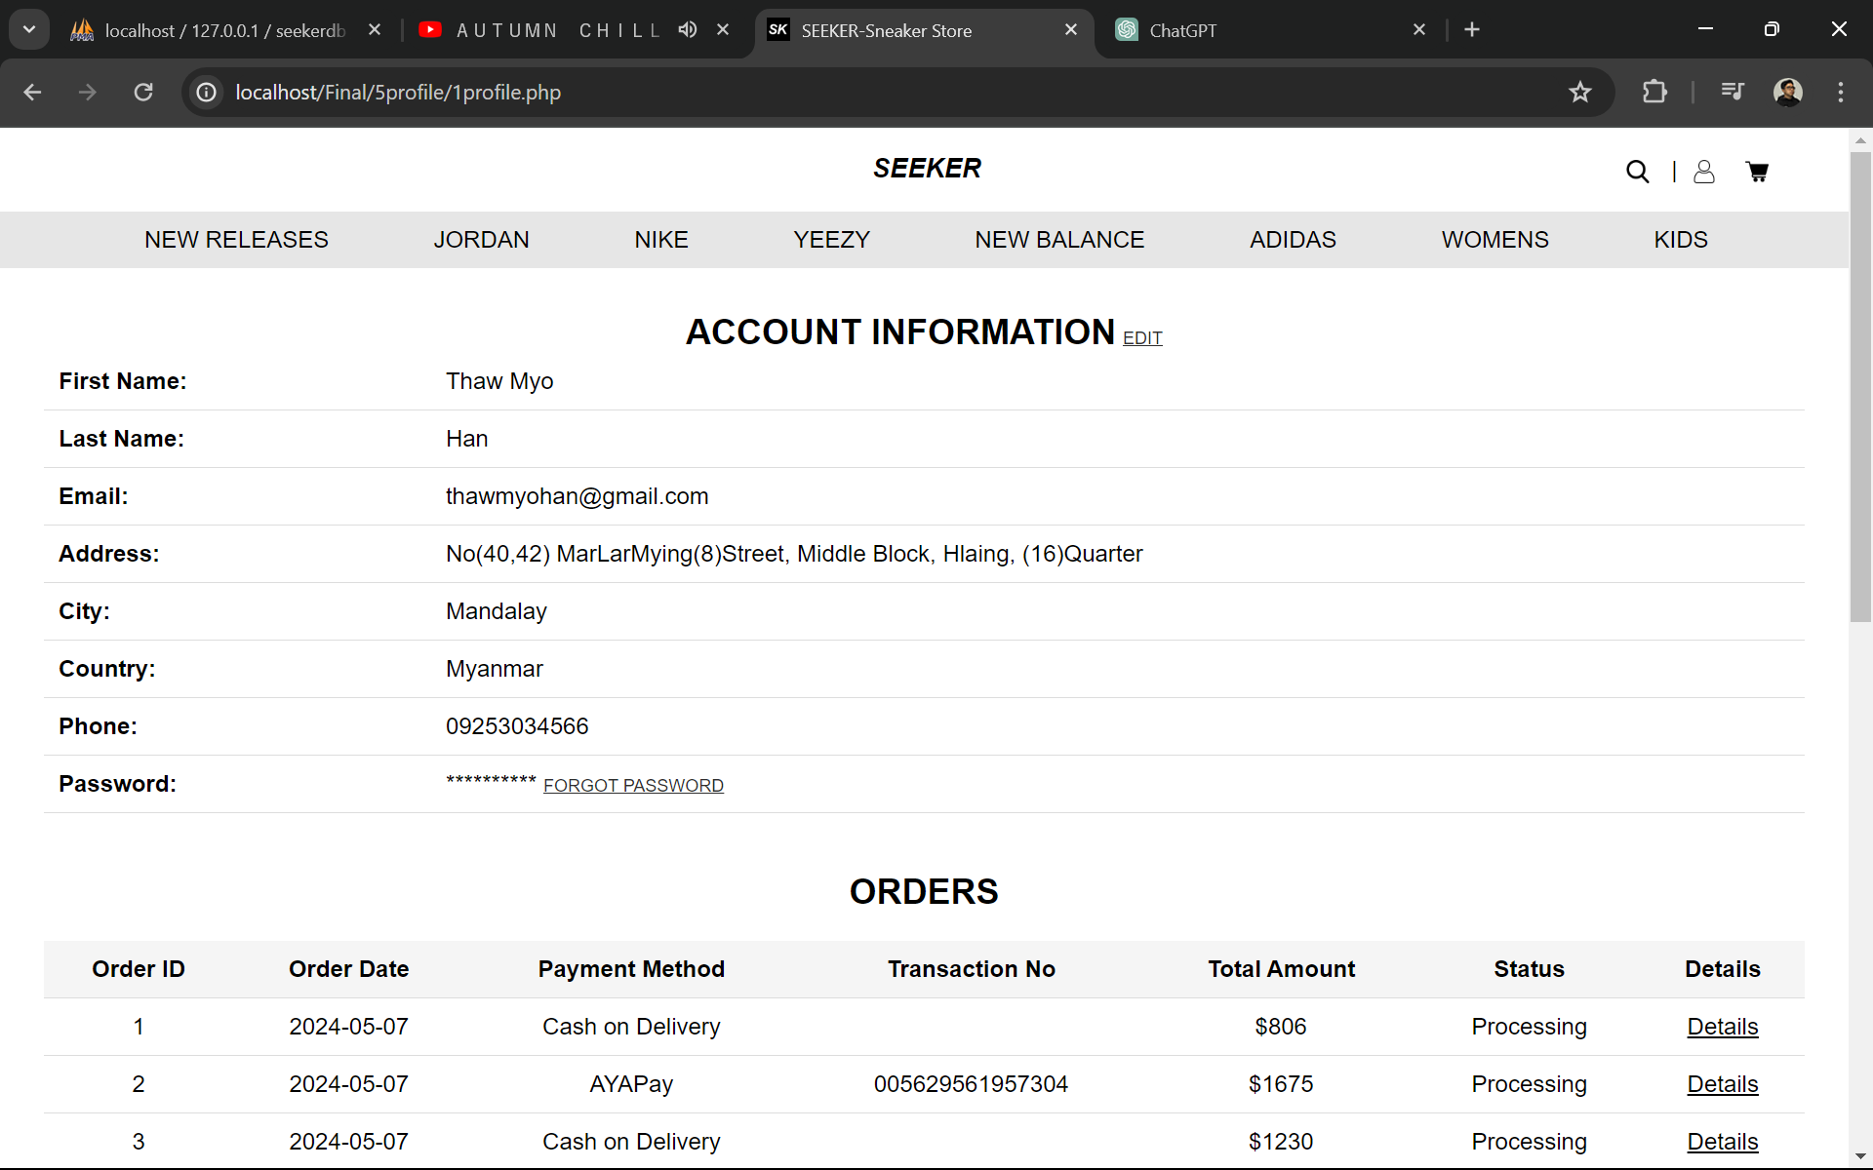

Figure 29 Profile

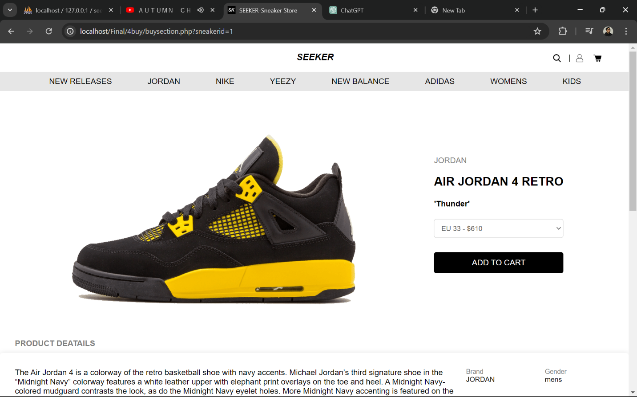

Figure 30 Available Sizes & Prices

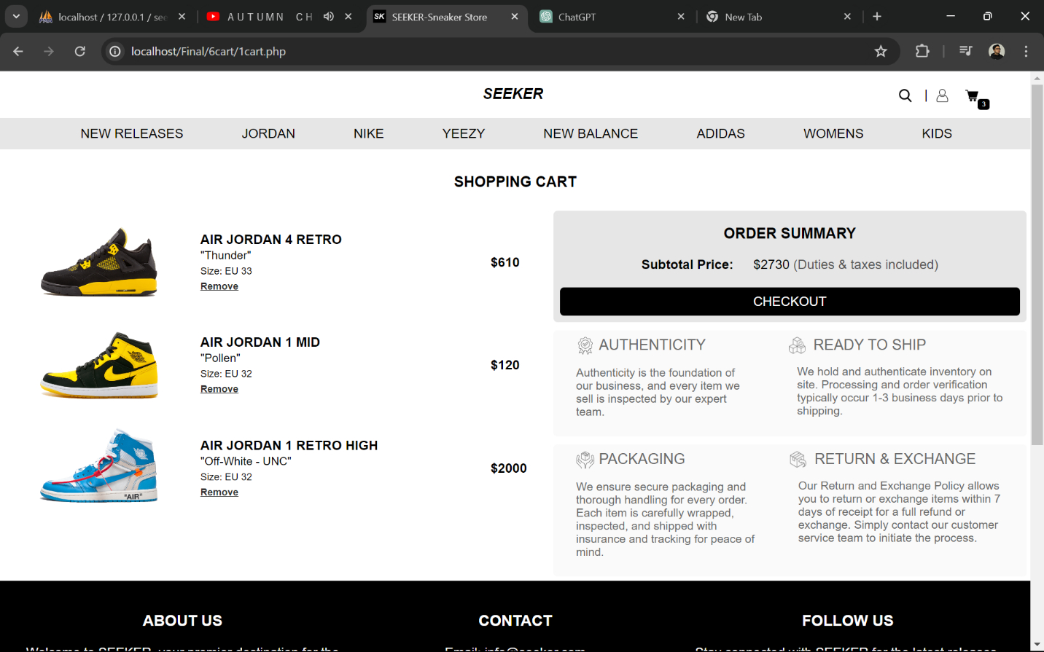

Figure 31 Cart

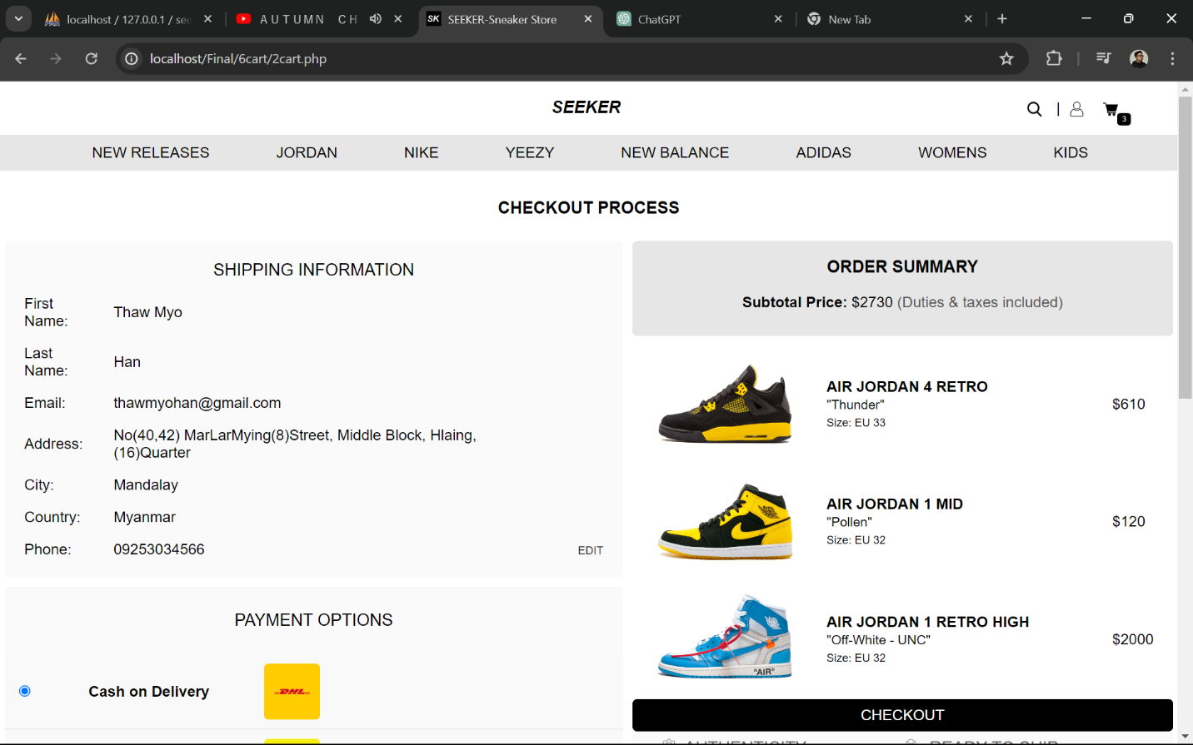

Figure 32 Check Out Process

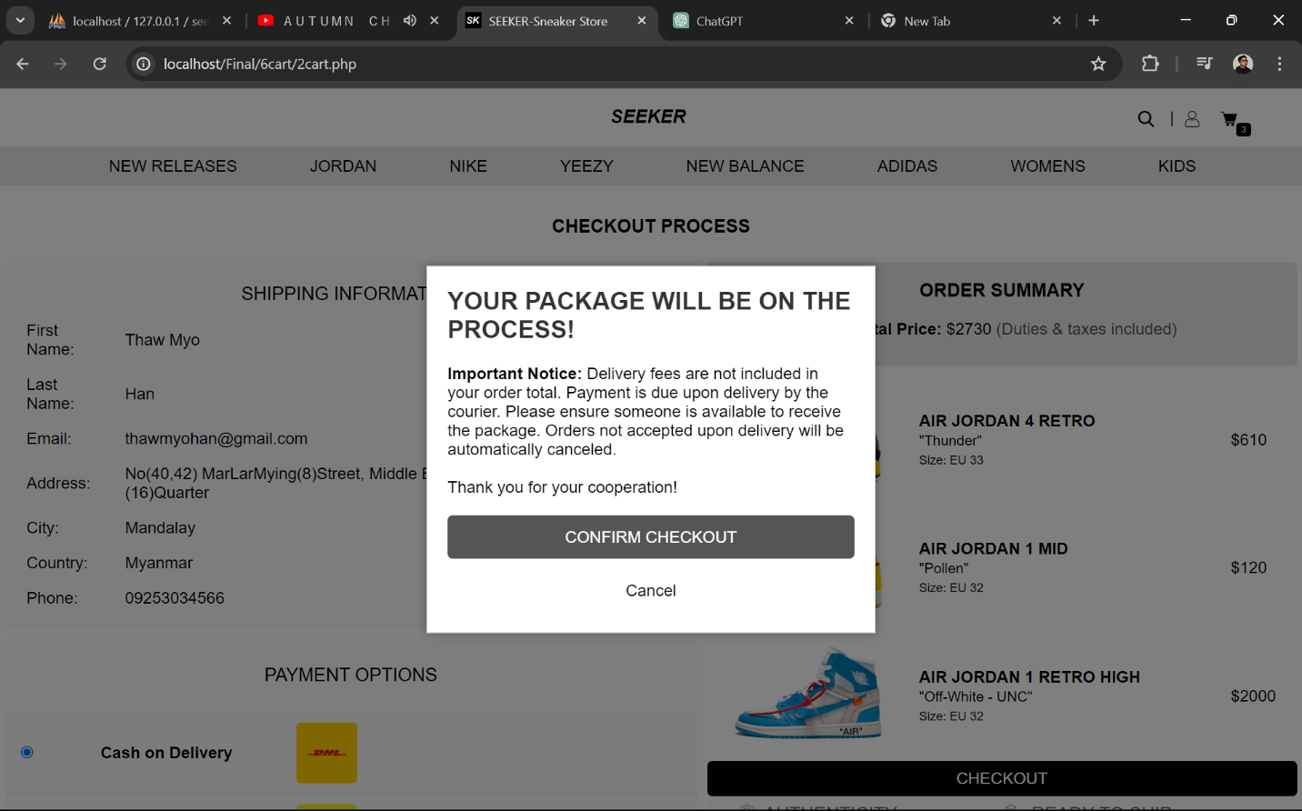

Figure 33 Confirmation

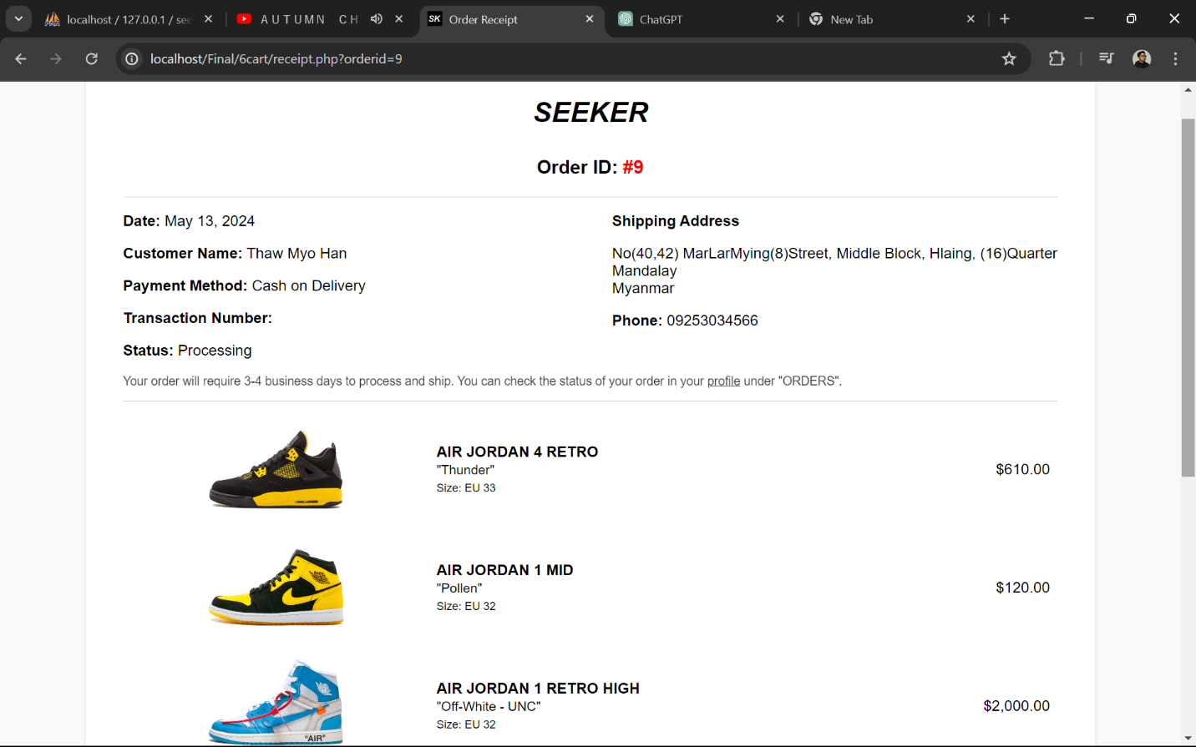

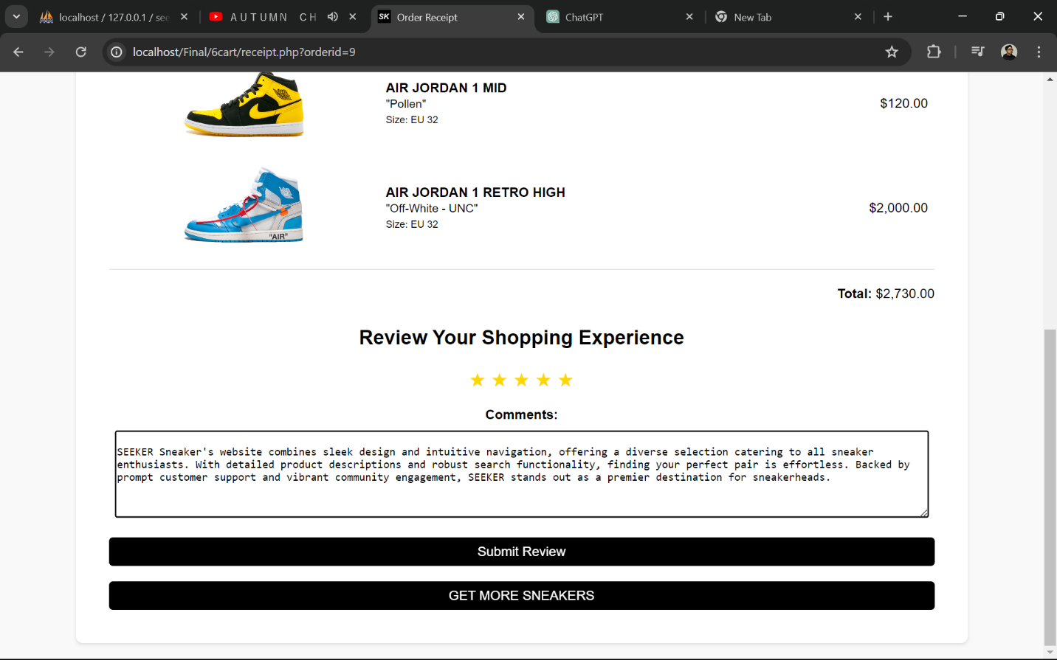

Figure 34 Receipt

## Security features of the system

**1. Control of Access**

* User Permissions: Access to features like purchasing and profile editing is exclusive to logged-in users.
* Registration Protocol: Ensure all mandatory fields (name, email, phone number, password) are completed during sign-up to prevent blank entries.
* Preventing Duplicate Accounts: Implement measures to stop users from registering with already existing email or phone numbers.
* Blocklist Verification: Users blocked by administrators cannot log in or register with the same email or phone number.

**2. Verification of Identity**

* Secure Login: Correct email and password are required for user login.
* Blocking Protocol: Users on the blocklist cannot access the site or log in.
* Session Management: Redirect blocked users attempting to access purchasing features to the login page for reauthentication.

**3. Profile Security**

* Restrictions on Profile Edits: Users can alter certain profile details (e.g., address, name) but are prohibited from changing critical information like email and phone number post-registration.
* Password Security: Enforce robust password standards (length, complexity) and establish a secure method for password recovery, including the use of security questions and answers for the "forgot password" or "change password" feature.

**4. Administrative Access**

* Data Confidentiality: Administrators can view user data but are not granted access to user passwords.
* User Account Oversight: Admins are limited from adding or removing user accounts to thwart unauthorized access or data tampering.

**5. General Security Measures**

* Error Management: Introduce error messages and validation checks to address potential security threats, such as input validation and form sanitization.
* Logging and Surveillance: Integrate logging and surveillance mechanisms to monitor and detect suspicious activities for security audit purposes

# SECTION D - TESTING DOCUMENTATION & IMPLEMENTATION

## TESTING

### Test Plan 1 Functional Testing

|  |  |
| --- | --- |
| **1.1 Product Listing and Details Testing** | |
| Objective | Confirm that products are accurately displayed with correct information and images on the SEEKER Sneaker Online Store Website. |
| Test Data | Product name: " AIR JORDAN 13 RETRO "  Description: A highly anticipated release from Nike's Jordan brand.    Figure 35 Test Data of 1.1 |
| Test Result | Details: Correct product name, description, prices, available sizes, and image of the AIR JORDAN 13 RETRO sneaker.    Figure 36 Test Result of 1.1 |

|  |  |
| --- | --- |
| **1.2 Search Functionality Testing** | |
| Objective | Ensure that the search feature returns relevant results based on user queries. |
| Test Data | Search for – Air Jordan 1    Figure 37 Test Data of 1.2 |
| Test Result | The search should return relevant results, including Air Jordan 1 in various sizes.    Figure 38 Test Result of 1.2 |

|  |  |
| --- | --- |
| **1.3 Cart and Checkout Testing** | |
| Objective | Test the shopping cart functionality, including adding/removing items and completing the checkout process smoothly. Validate the process for selecting payment methods during checkout. Verify that the available sneaker quantity is accurately reflected during the checkout process. |
| Test Data | Product: " AIR JORDAN 1 RETRO HIGH OG"  Size: EU 42  Product: " KYRIE 3 MM"  Size: EU 42  Remove : KYRIE 3 MM EU 42  Payment Method: AYA Pay or Cash on Deli  AYA Pay Transaction No: 04849673017592750375 |
| Test Result | Product: " AIR JORDAN 1 RETRO HIGH OG" Size: EU 42    Figure 39 Test Result of 1.3  Product: " KYRIE 3 MM" Size: EU 42    Figure 40 Test Result of 1.3  Cart Lists    Figure 41 Test Result of 1.3  Remove a sneaker from a cart    Figure 42 Test Result of 1.3  Check Out Process    Figure 43 Test Result of 1.3  If customer choose Cash on Delivery, Confirmation Box will appear.    Figure 44 Test Result of 1.3  If customer choose AYA Pay or other, Transaction Box will appear.    Figure 45 Test Result of 1.3  Receipt    Figure 46 Test Result of 1.3 |

### Test Plan 2 Security Testing

|  |  |  |  |  |  |
| --- | --- | --- | --- | --- | --- |
| **2.1 Customer Blocking Testing** | | | | | |
| Objective | | | Test the system's response to customers who have been blocked according to company policies, ensuring they cannot access restricted areas or perform unauthorized actions. | | |
| Test Data | | | Customer ID: 1  Customer Name: Thaw Myo Han  Block Status: Block (1)  Administrator: Customer Manager from CMC (Customer Management Center) | | |
| Test Result | | | Customer Manger can view customer lists and find out that which customer need to block account.    Figure 47 Test Result of 2.1  Customer ID 1 – Thaw Myo Han’ s account is blocked due to the company policies.    Figure 48 Test Result of 2.1  For a customer, he or sher cannot be able to login with the email and password.    Figure 49 Test Result of 2.1  The blocked message will be announced.    Figure 50 Test Result of 2.1  If the customer is already logged in with the blocked account, he or she may not be continued to buy or view sneakers and redirect to the login page with above the blocked message. | | |
| **2.2 Registration Validation Testing** | | | | |
| Objective | | | Validate that registered email addresses and phone numbers cannot be duplicated, enhancing data integrity and security. | |
| Test Data | | | Registered Email: [thawmyohan@gmail.com](mailto:thawmyohan@gmail.com)  Registered Phone: 09253034566 | |
| Test Result | | | New customer try to fill the registered email and password to create a new account.      Figure 51 Test Result of 2.2  When new customer signs up, the messages will be shown.    Figure 52 Test Result of 2.2 | |
| **2.3 Session Security Testing** | | | |
| Objective | | | Verify that users are securely logged out of their accounts and cannot return to previous pages using browser back functions after logging out. |
| Test Data | | | Customer Email: [thawmyohan@gmail.com](mailto:thawmyohan@gmail.com)  Customer Password: Thawmyohan002@  Test: Log Out & Use browser back functions to check security of website. |
| Test Result | | | Customer can log out in his or her profile and the button will be declared with red button.      Figure 53 Test Result of 2.3  Upon logging out, customers are redirected to the homepage. However, due to the high security measures in place, using the browser's back function to return to the previous page is not permitted.  Figure 54 Test Result of 2.3  It redirected to login page.    Figure 55 Test Result of 2.3 |

## System implementation

### An implementation plan including conversion procedures

The implementation plan for the Seeker Sneaker Online Store website outlines the steps and procedures to be followed to successfully deploy the website from the development environment to the production environment. This plan includes details on testing, data migration, training, and support to ensure a smooth transition and minimal disruption to operations.

**Implementation Activities**

|  |  |  |
| --- | --- | --- |
| **Activities** | **Description** | **Responsible Party** |
| Planning | Finalize and review the implementation plan to ensure all aspects are covered. | Project Manager |
| Backup Current Data | Perform a complete backup of all existing data and systems to prevent data loss. | IT Team |
| Server Setup | Set up and configure the production server environment to host the online store. | IT Team |
| Install E-commerce Platform | Install and configure the chosen e-commerce platform on the server. | IT Team |
| Data Migration | Migrate all existing product, customer, and transaction data to the new platform. | Data Base Designer |
| Testing | Conduct comprehensive testing to ensure all functionalities work as expected. | Quality Assurance (QA) Team |
| Staff Training | Train staff on the new system, focusing on order processing and customer management. | Training Team |
| Soft Launch | Launch the website with limited access to identify and resolve any issues. | Project Manager |
| Full Launch | Officially launch the website to the public. | Project Manager |
| Post-launch Support | Provide ongoing support and troubleshoot any issues that arise. | IT Support Team |

**Conversion Procedures**

|  |  |
| --- | --- |
| **Procedure** | **Description** |
| Data Backup | Ensure that all current customer data, product inventory, and transaction records are securely backed up prior to commencing the conversion process. |
| Data Migration | * Export data from the existing system in a compatible format. * Cleanse the data to remove duplicates and correct any inconsistencies. * Import the cleansed data into the new e-commerce platform, ensuring proper field mapping. |
| System Testing | * Perform functional testing to verify that all features (such as product browsing, shopping cart, checkout process, payment gateway, and user accounts) are working correctly. * Conduct load testing to ensure the website can handle expected traffic volumes. * Carry out security testing to identify and rectify any vulnerabilities. |
| Staff Training | * Conduct thorough training sessions for staff. * Navigation and use of the new system. * Order processing and inventory management. * Handling customer queries and issues. * Develop and distribute detailed user manuals and quick reference guides. |
| Soft Launch | * Implement a soft launch by granting access to a small group of users to identify and address any issues. * Collect feedback and make necessary adjustments before the full launch. |
| Full Launch | * Officially launch the website to the public. * Closely monitor the website during the initial days to ensure smooth operation. |

# Section E - Critical Appraisal

## Limitations of the System

While the Seeker Sneaker online store website presents a promising platform for e-commerce, several limitations need consideration:

* **Limited Customization Options**: The current system may lack flexibility in terms of customization, potentially restricting the implementation of unique features or design elements tailored to specific customer preferences.
* **Scalability Concerns**: As the business grows and user traffic increases, scalability may become an issue. The current system architecture might struggle to accommodate a larger volume of users and transactions without significant upgrades.
* **Security Vulnerabilities**: Despite rigorous testing, there is always a risk of security vulnerabilities, such as data breaches or hacking attempts. Continuous monitoring and updates are essential to mitigate these risks effectively.
* **Mobile Responsiveness**: While efforts have been made to ensure mobile responsiveness, there may still be areas where the user experience on mobile devices could be improved. This could impact customer satisfaction and particularly as mobile shopping continues to rise in popularity.

## Recommended Changes

To address the identified limitations and enhance the overall effectiveness of the Seeker Sneaker online store website, the following changes are recommended:

* **Enhanced Customization Options**: Invest in the development of a more flexible and customizable platform that allows for easier integration of new features and design elements. This will enable the website to adapt quickly to changing market trends and customer preferences.
* **Scalability Planning**: Conduct regular assessments of the system's scalability and implement measures to ensure smooth growth. This may involve optimizing server infrastructure, adopting cloud-based solutions, or implementing content delivery networks (CDNs) to handle increased traffic effectively.
* **Continuous Security Updates**: Implement a robust security protocol that includes regular vulnerability assessments, penetration testing, and timely patching of software vulnerabilities. Additionally, consider investing in advanced security technologies such as web application firewalls (WAFs) and intrusion detection systems (IDS) to proactively defend against cyber threats.
* **Mobile Optimization**: Prioritize mobile optimization by adopting a mobile-first approach to website design and development. Ensure that the user experience is seamless across all devices, with intuitive navigation, fast loading times, and responsive design elements that adapt to various screen sizes.

## Critical Reflection of the Project Experience

The development and implementation of the Seeker Sneaker online store website have been a valuable learning experience, providing insights into the complexities and challenges of e-commerce platforms. Through this project, several key reflections emerge:

* **Collaborative Effort**: The success of the project depended heavily on effective collaboration and communication among team members. Clear roles, responsibilities, and regular meetings were essential for maintaining project momentum and achieving milestones.
* **Adaptability and Flexibility**: The agile development approach allowed for flexibility in responding to changing requirements and feedback. This adaptability was crucial in addressing evolving customer needs and market dynamics throughout the project lifecycle.
* **Continuous Improvement**: The project highlighted the importance of continuous improvement and iteration. Regular feedback loops and post-launch evaluations facilitated the identification of areas for enhancement, driving ongoing optimization and refinement of the online store platform.
* **Customer-Centric Approach**: At the core of the project was a commitment to delivering a customer-centric shopping experience. User feedback and usability testing played a vital role in shaping the website's features and functionalities, ensuring that it met the needs and expectations of the target audience.